

College of Information and Computing Sciences
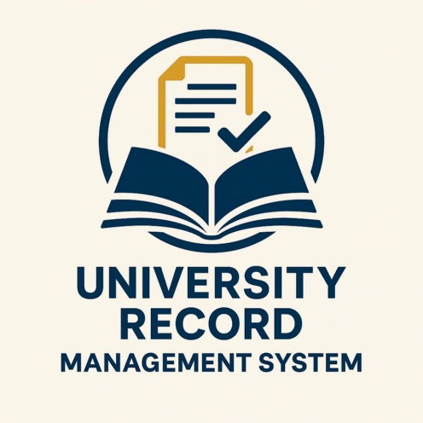

University Records Management System
Software Requirement Specification

Information Technology Project 2025

Submitted by:

HECTOR N. REYNON JR.
KATRINA A. AGASA
NICOLE ANN ANTALAN
SHARMAINE CABANGLAN

Submitted to:

ALBERT A. CANLAS

Date of submission
AUGUST 2025
Table of Contents
Table of Contents ii
Revision History ii
1. Introduction 1
1.1 Purpose 1
1.2 Document Conventions 1
1.3 Intended Audience and Reading Suggestions 1
1.4 Product Scope 2
1.5 References 3
2. Overall Description 3
2.1 Product Perspective 3
2.2 Product Functions 3
2.3 User Classes and Characteristics 6
2.4 Operating Environment 7
2.5 Design and Implementation Constraints 7
2.6 Project Documentation 7
2.7 User Documentation 8
2.8 Assumptions and Dependencies 8
3. External Interface Requirements 9
3.1 User Interfaces 9
3.2 Hardware Interfaces 11
3.3 Software Interfaces 11
3.4 Communications Interfaces 11
4. System Features 12
4.1 E-R Diagram 12
4.2 Use Case Diagram 13
4.3 Use Case Scenarios 13
4.5 Activity Diagrams 17
5. Other Nonfunctional Requirements 21
5.2 Performance Requirements 21
5.3 Safety Requirements 21
5.4 Security Requirements 21
5.5 Software Quality Attributes 21
5.6 Business Rules 22
6. Other Requirements 22
Appendix A: Glossary 23

Revision History
Name | Date | Reason For Changes | Version

Introduction

Purpose

The Software Requirement Specification document goes ahead to elaborate on the specific requirements for the University Record Management System (URMS), which include functional and non-functional specifications of the software and an operational overview of the anticipated system in the target environment.

URMS application is a desktop application written as Windows Forms in C# using Visual Studio, and it communicates with a MySQL database. The primary purpose of URMS is to ease administrative work concerning student and professor record management operations in a university. It incorporates secure login management to the admin, CRUD operations on students and professors, gives a more overview through the dashboard, Data grid views, and real-time updates, along with search.

URMS provides easy record handling by administrators of the university through a user-friendly graphical interface for such operations as managing student profiles (ID, name, college, course, year level, and photo) and professor records (ID, full name, course, subject, and photo), including electing numbers of students and professors.

The project is geared toward improved academic records' accuracy, accessibility, and organization, leading to better data governance and administrative efficiency.

Document Conventions
The document has been prepared using Microsoft Word 2013, and the type used is Times New Roman. The fixed font size that has been used in typing this document is 12pt and 1.5 spacing in lines. Used a bold face to assign headings to the document. The use-case scenario is written based on Alistair Cockburn's template. UML diagrams are drawn as per UML 2.0 standards. The standard IEEE template is the template used for organizing the document's appearance and flow.

Intended Audience and Reading Suggestions
This Software Requirements Specification (SRS) Document is for Users and Groups involved directly in Development, Testing, Deployment, and Evaluation of the University Record Management System (URMS). The primary audience includes software developers against whom the document is designed to direct implementation of feature usages; system analysts and architects interpret the behaviour and interactions generated by the system; project managers follow the system progress tracking it as formulated toward the objectives it is destined to achieve. It is a document of great importance also to quality assurance engineers who will be in charge of verifying the system's functions, university IT personnel who oversee the deployment stage and maintenance phase in the long-term period, and academic evaluators or instructors assessing the capstone project. The document has been organized in such a way as to allow nonlinear reading; readers are encouraged to jump to the right sections depending on their roles. Brief outline of the document is thus:
1. Overall Description
2. System Features
3. External Interface Requirements
4. Non-Functional Requirements

Product Scope
The University Record Management System (URMS) is built to digitalize and automate student and faculty record handling processes within a university. The system provides the following functionality:
- Secure Admin Login with show/hide password functionality.
- Student Management: Add, update, delete, and view students with full academic profile and photo.
- Professor Management: Add, update, delete, and view professor information including subjects and photos.
- Dashboard Interface: Displays total students, total faculty, and options to manage records.
- Search and Filtering: For both student and professor modules.
- Real-time Data Grid Views: Reflect changes automatically upon add/update/delete.
- Future Enhancement-Ready: Structured to accommodate grading, subject enrollment, and course scheduling modules.

References
What is a University Records Management System? (2023). Records Management Standards Online. Retrieved from: https://www.recordsmanagement.com/university-records-management

Best Practices for Student Information Systems. (2024). EdTech Magazine. Retrieved from:
https://edtechmagazine.com/k12/article/2024/01/best-practices-student-information-systems

Data Privacy in Higher Education. (2023). International Association of Privacy Professionals (IAPP). Retrieved from: https://iapp.org/resources/article/data-privacy-in-higher-education

University Records Management Policy. (2024). University of Cambridge. Retrieved from: https://www.cam.ac.uk/university-records-management-policy

Overall Description

Product Perspective
This newly developed software application will basically assist in managing all manner of academic records of an educational institution. With its user-friendly and intuitive window-based interface, it can be navigated with ease even by people with limited technical expertise. It is aimed at addressing the common challenges of administrators with respect to data handling being drowned in paperwork to poorly organized record retrieval. The introduction of the software automates crucial operational functions like student and professor data management, report generation, and secure access control, thereby boosting accuracy, reducing human error, and speeding up administrative workflows. The basic structure of the software will be laid down to give role-based admin access, enabling them to perform high-level tasks while ensuring both data integrity and data security. The system also improves overall institutional efficiency due to real-time data updates and the inbuilt tools to manage student and faculty records.

Product Functions
Some core functionalities of the University Records Management System include adding, editing, deleting, and viewing of student and professor records; user account management; assigning subjects and courses; displaying pictures for identification; and viewing dashboard analytics for total students and faculty, and secure log in and log off. Other functionalities include search functionality, auto-updating data grids showing real-time visibility of added records.
Functional Requirements:
- Add, Update, Delete Student Records
- Add, Update, Delete Faculty Records
- Manage Courses and College Information
- Print Student and Faculty Records
- Display Dashboard Summary (Total Students, Total Faculty)
- Admin Login and Session Management
- Generate Reports
- Search and Filter Records
Admin:
- Can log in securely
- Can manage (Add, Update, Delete) student and professor records
- Can manage course and college information
- Can print and generate reports
- Can log out of the system securely
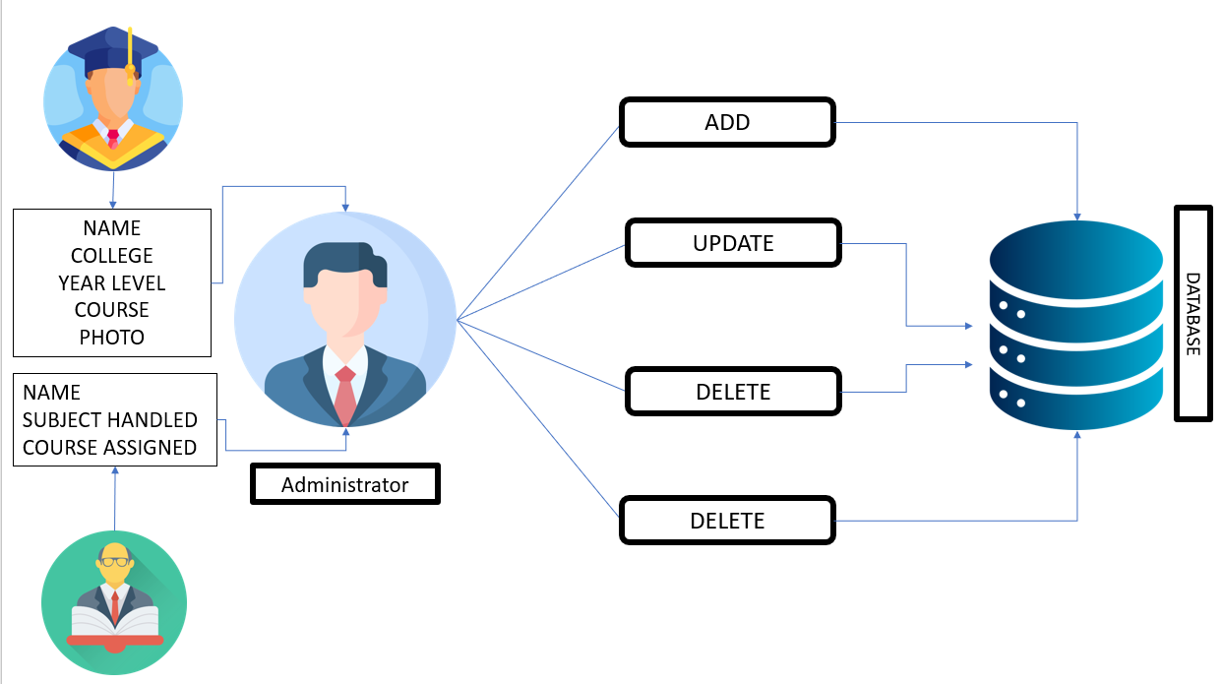
Figure 2.1.1 High Level Architecture

Functional Requirements

Function 1 | Dashboard Overview
Input | System Data
Output | Total Number of Students and Faculty
Processing | Aggregate data from the database and update the dashboard display in real time.

Function 2 | Add Student
Input | Student ID, Full Name, College, Course, Year Level, Photo
Output | Database Record, Database successfully updated message
Processing | Validate the given details and record the information into the database.

Function 3 | Add Professor
Input | Professor ID, Full Name, Course Handled, Subject Taught, Photo
Output | Database Record, Database successfully updated message
Processing | Validate the given details and record the information in to the database.

Function 4
  Search Records
Input | Search Keywords (e.g., Name, ID, Course)
Output | Filtered records displayed in the data grid
Processing | Match input keywords with existing records and update the displayed data in real-time.

User Classes and Characteristics

User Classes
There are two user levels in University Records Management System:

- Administrator
- Registrar Staff

Characteristics of User Classes
Administrator: The administrator has complete dominion over the system and is responsible for its configurations, the management of users, updates to data structures, and generally administration of the entire database. This profile must appreciate technological concepts, maintain a level of trust, and be trained to handle sensitive data. The administrator ensures safety regulations are maintained and that proper backups are performed.

Registrar: These users take care of the daily operations regarding student-and-faculty records. They encode, edit, delete, and print records and reports. They should also pay attention to detail, have knowledge of basic IT principles, as well as the academic structures and policies. Their work is primordial for ensuring that academic records remain accurate and up to date.

Operating Environment
Hardware and software requirements

Hardware:
- Operating System Supports all known operating systems, such as Windows, Linux
- Computer 512MB+ RAM, monitor with minimum resolution of 1024x768, keyboard, and mouse
- Hard Drive should be in NTFS filesystem formatted with minimum 10 GB of free space
- A Laser printer will need to be used to print these reports and notes

Software:
- Software is designed to run on any platform above Microsoft Windows 7 (32bit).
- Microsoft .NET Frameworks 4.0 or above.
- Microsoft SQL Server Management Studio Express 2010.

Design and Implementation Constraints
For security and usability, the system employs access control, modular coding, and encrypted storage of passwords. The software has been developed using C# and Windows Forms, with a MySQL backend database. The system is not currently accessible via mobile technology. Designs are aimed at ease of use by non-technical professionals.

Project Documentation
Project Documentation is the section that describes in brief all details about the documents created by the project team up to now. It includes the Project Charter and Project Proposal.

• Project Charter: Contains team members, objectives, and a high-level overview of the system's goals.
• Project Proposal: Identifies problems associated with the manual record system and how the URMS meets those problems through digitization and automation.

User Documentation
A more comprehensive user manual will be made available, to guide the staff in using the system. The manual is written in plain text and is filled with screenshots and step-by-step descriptions on how to add records, print reports, and login-out. The manual is placed within the system to facilitate access.

Assumptions and Dependencies
It has been assumed that the university will be providing necessary hardware and software requirements. It has also been assumed that training will be given to the staff for using the system. The SRS and software may also require updates if the university changes its operating system or any database technology. The effectiveness of the system also depends on regular maintenance and adherence by the users to the proper usage protocol.

External Interface Requirements

User Interfaces
User friendly dashboard of the University Records Management System
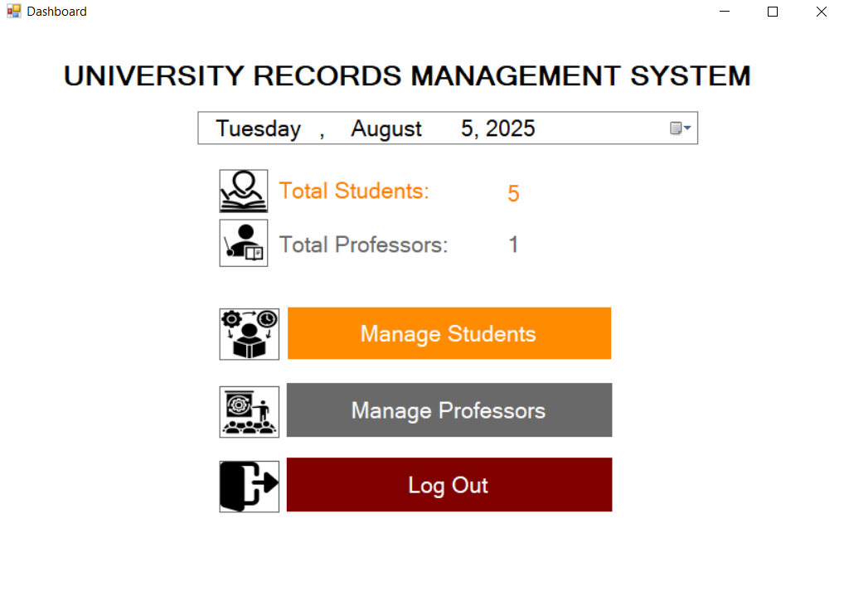

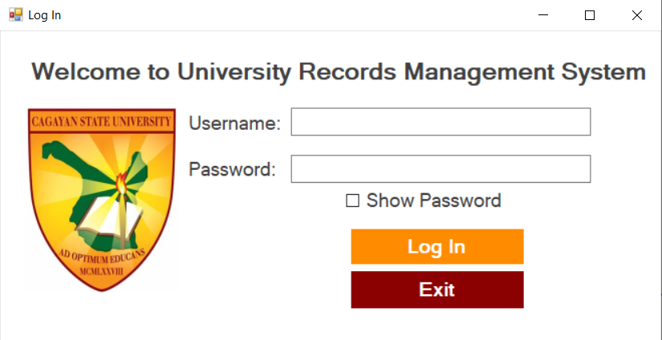
Login interface is used to login to the system using username and password.
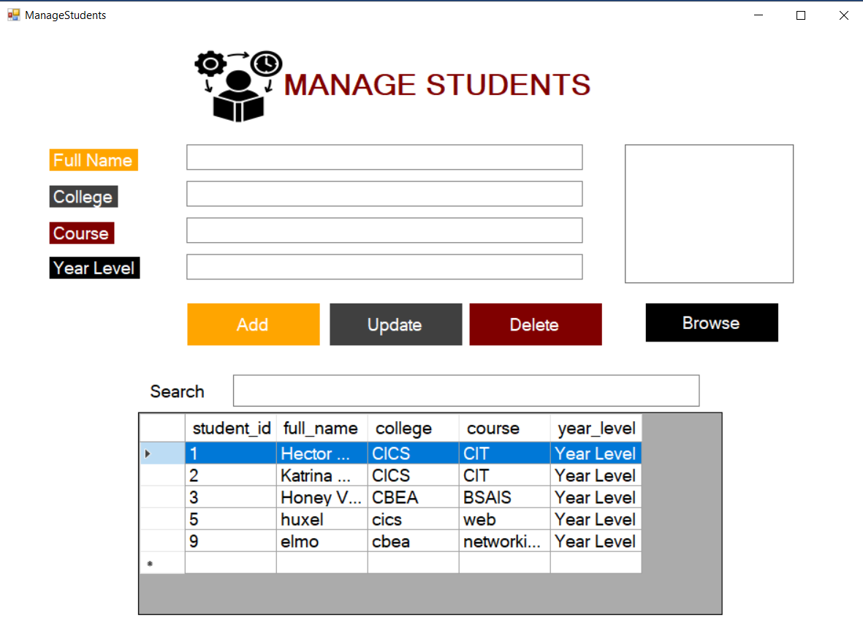
Adding new student records and managing added records on the system.

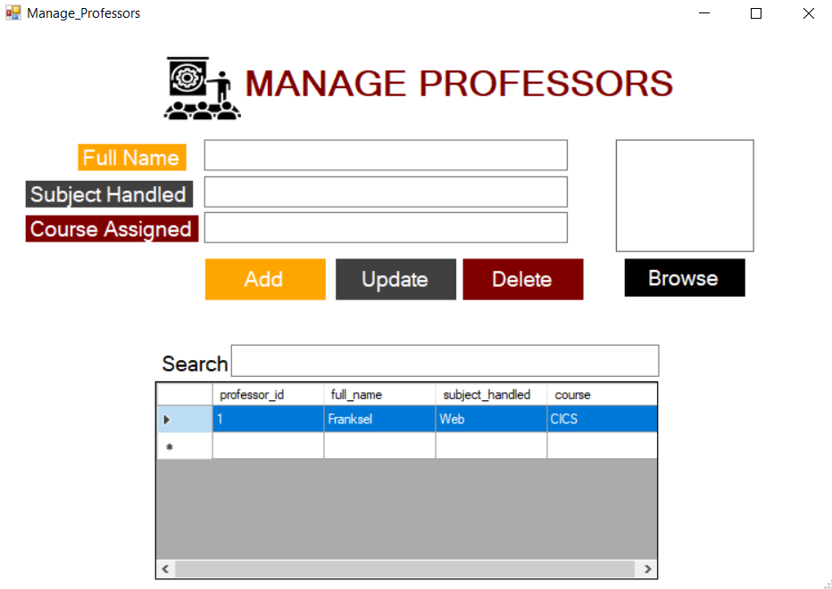
Adding new professor records and managing added records on the system.

Hardware Interfaces
Certain specifications for computers must be matched so as to allow the system to work at its own pace and for the best performance for URMS. These devices should have persistent internet access so data can be synchronized. Furthermore, it is recommended that a laser printer be used to print student and faculty records, as well as official reports.

Software Interfaces
URMS will be implemented on Microsoft Windows environment and will communicate with MySQL database for data storage and management. The development will be done using C# on Visual Studio, where Crystal Reports will be used for report generation. The system will have a direct interface with printer drivers, MySQL connectors, and .NET libraries.

Communications Interfaces
The system does not support notifications via e-mail or SMS. However, real-time synchronization of data amongst different departments and users will demand a strong internet access. All communications of any kind related to the updates or changes of database will have to be performed manually by university personnel. Manual or printed reports will continue as before through the system.

System Features

E-R Diagram
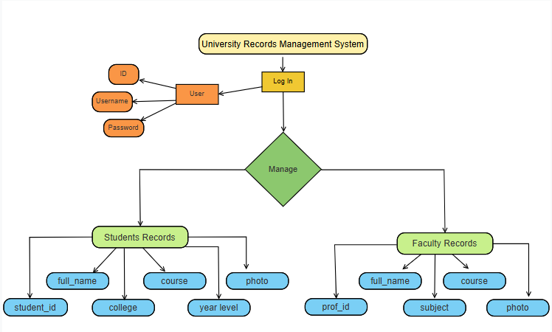

Use Case Diagram
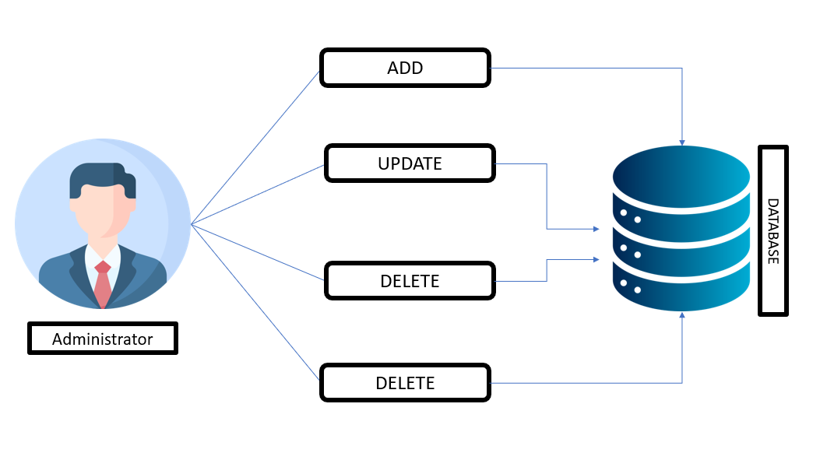

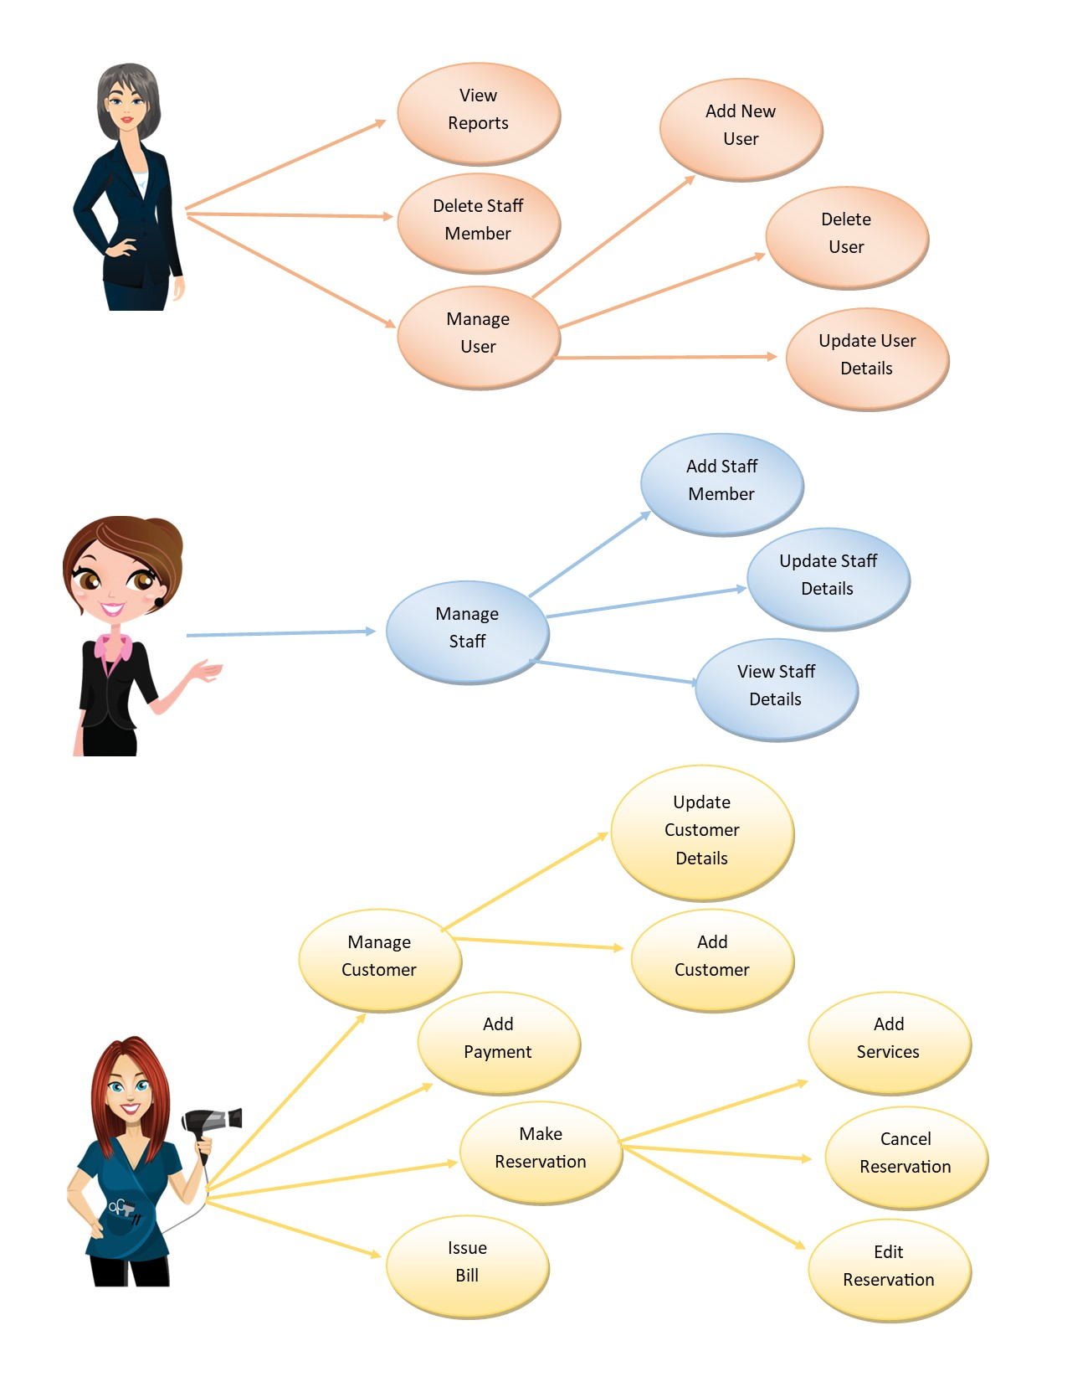

Use Case Scenarios
1)
Use case Name | Add Student Record
Goal | Add a new student to the system
Primary Actors | Admin
Secondary Actors | None
Precondition | Admin must be logged in
Post condition | New student record stored in the database
Triggers
Main flow | Step | Action
Main flow | 1 | Admin enters student details/records.
Main flow | 2 | System displays student form
Main flow | 3 | Admin selects “Add Student” option
Main flow | 4 | System validates data and student record saved into database
Main flow | 5 | System confirms successful entry
Extensions

Extensions | 4.1 | If data is invalid, system shows error message

2)

Use case Name | Add Faculty Record
Goal | Add a new professor to the system
Primary Actors | Admin
Secondary Actors | None
Precondition | Admin must be logged in
Post condition | New professor record stored in the database
Triggers
Main flow | Step | Action
Main flow | 1 | Admin enters professor details/records.
Main flow | 2 | System displays professor form
Main flow | 3 | Admin selects “Add Professor” option
Main flow | 4 | System validates data and professor record saved into database
Main flow | 5 | System confirms successful entry
Extensions | 4.1 | Missing or invalid data triggers an error

3)

Use case Name | View Dashboard Statistics
Goal | View summarized data like total students/faculty
Primary Actors | Admin
Secondary Actors | None
Precondition | System must be running properly
Post condition | Dashboard displayed with updated data
Triggers | Admin logs in or refreshes dashboard
Main flow | Step | Action
Main flow | 1 | System loads dashboard UI
Main flow | 2 | Queries database for stats
Main flow | 3 | Displays total students and faculty
Main flow | 4 | Refresh available if needed
Extensions

Extensions | 2.1 | Database fails to load, show “Error loading dashboard”
4)
Use case Name | Edit Student/Faculty Information
Goal | Update existing information
Primary Actors | Admin
Secondary Actors | None
Precondition | Student/Faculty Record must exist
Post condition | Updated student/faculty details saved in database
Triggers | Admin selects “update” button
Main flow  Extensions | Step | Action
Main flow  Extensions | 1 | Admin searches student and faculty by ID or name
Main flow  Extensions | 2 | System fetches existing details
Main flow  Extensions | 3 | Admin updates fields
Main flow  Extensions | 4 | System validates and saves changes
Main flow  Extensions | 5 | System confirms update success
Main flow  Extensions | 4.1
  If update fails, show error message

5)
Use case Name | Delete Student/ Faculty records
Goal | Remove a student/faculty record from the system
Primary Actors | Admin
Secondary Actors | None
Precondition | Student/faculty record must exist
Post condition | Record removed from the database
Triggers | Admin selects “delete” button
Main flow | Step | Action
Main flow | 1 | Admin searches for student/faculty records
Main flow | 2 | System shows matching result
Main flow | 3 | Admin confirms deletion
Main flow | 4 | System deletes record from database
Main flow | 5 | Success message shown
Extensions

Extensions | 2.1 | If student/faculty not found, show “Not Found” error

4.5 Activity Diagrams
Log In

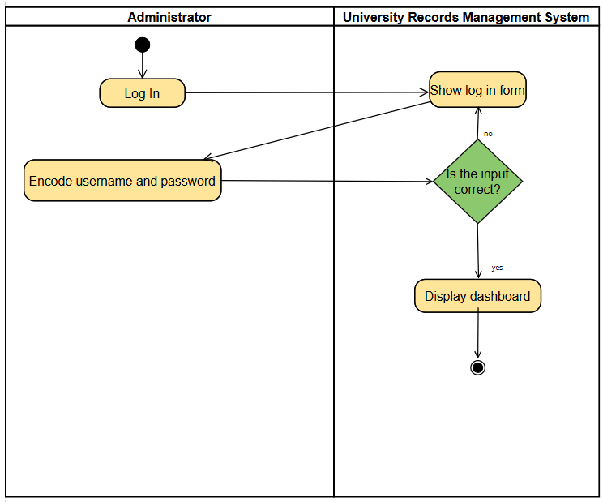

Add Student/Faculty Records

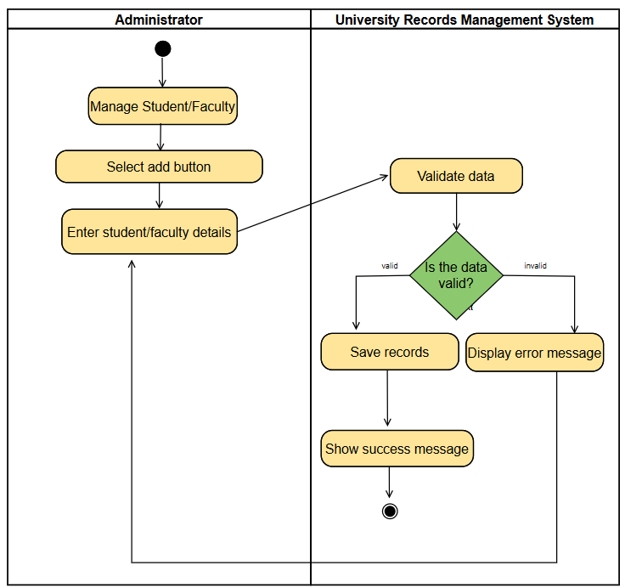
Delete Student/Faculty Records

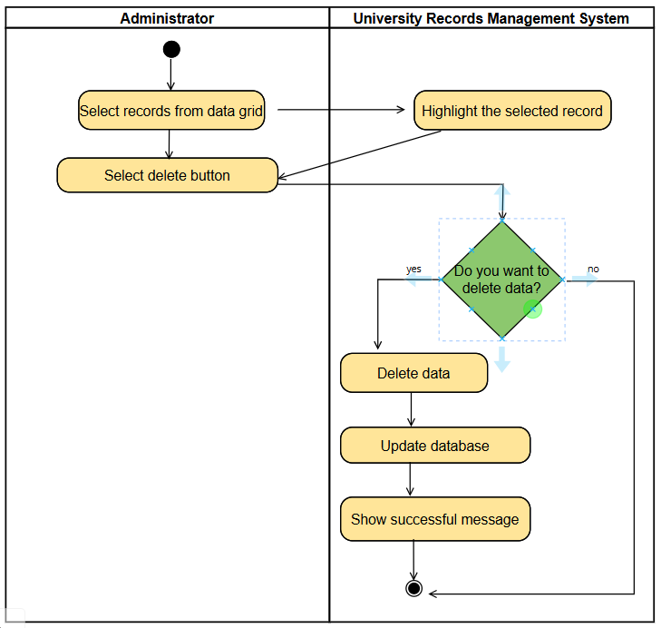

Update Student/Faculty Records

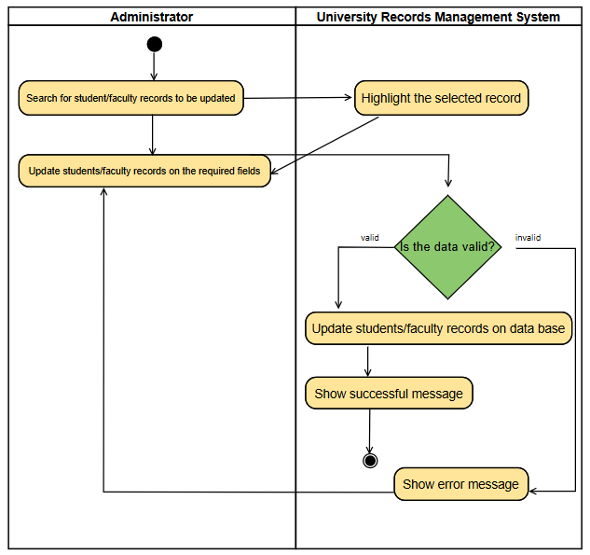

Other Nonfunctional Requirements

Performance Requirements
The system is meant to respond within agreeable limits in order to be cost-effective for administrators and staff alike. The URMS is designed to be a thin client application, meaning that it should work with very limited hardware. However, its effective operation lies with the hardware and software environment where it will run.

Safety Requirements
URMS uses role-based access control whereby some specific access permissions are given to users including admins and registrar staff, since these users are the main ones who interact with sensitive academic records. This ensures that unauthorized access to such records is denied. All users must log in with a valid name and password to enhance the security of the system. Each user has a personal responsibility to protect the confidentiality of their login credentials. The system also extensively logs all accesses and error messages for monitoring irregular or unauthorized activities. This enables the protection of the system against data loss, malicious use, or inadvertent errors, thus maintaining university records' integrity and confidentiality.

Security Requirements

Authentication shall be applied to all URMS users. Admins and registrars, as such, are the only ones with permission to perform sensitive functions like modification and deletion of a record. To protect user credentials, the data in the database will be labeled as encrypted. Role access control is a method through which the action of the user is controlled against the deeds of the data. Data access is restricted in accordance with the variable privileges an individual holds. All student-faculty sensitive information is protected under the privacy standard. Very strong backup and recovery procedures should be put in place to avoid losing data while in case of any unforeseen failure of the system.

Software Quality Attributes
- Availability: The system shall be available during official office hours (8 AM–5 PM).
• Correctness: All modules are thoroughly tested to ensure data accuracy.
• Efficiency: The system minimizes delay in processing and querying records.
• Flexibility: New features or modules (e.g., additional reports) can be integrated.
• Integrity: Data integrity is maintained through relational constraints and validations.
• Maintainability: System code and interface are structured for easy maintenance.
• Portability: The URMS can run on any Windows-based system and is adaptable to future platforms.
• Reliability: The system is expected to have high uptime and recover quickly from failures.
• Reusability: Components such as login, search, and print modules can be reused.
• Testability: The system is modular and easy to test in isolation.
• Usability: The user interface is intuitive and accessible to staff with minimal training.
• Robustness: The system can handle unexpected inputs and continue to operate correctly.

Business Rules
The University Records Management System (URMS) will have only one main user role: Admin.
The system can be accessed by the admin once the right username and password are typed in. If the two are correct and therefore authentication is successful, the admin will be allowed to access the dashboard of the system. Otherwise, in case of login failure, the admin will have to re-enter the correct credentials. In fact, the admin is the only person who entertains full manipulation, editing, and deletion of records in the system, which ensures the data security and integrity of the university records. Unauthorized persons have no access to or cannot modify sensitive records of the university.

Other Requirements

As soon as the URMS is ushered into the entire institution, training sessions will run for the admin on the system's functions and processes. Afterward, there will be a member of the development team to render the agreed support for monitoring, assistance in adjustment, and fixing any system faults post-deployment.
During this time, any unforeseen bugs or improvements that were previously unnoticed will start to be fixed within the system to ensure its smooth operation.

Appendix A: Glossary

Student Record-the stored profile of a student, including ID, full name, college, course, year level, and a photo.

Faculty Record-this refers to the stored profile of a professor which comprises and includes ID, full name, course handled, subject taught, and a photo.

Dashboard-main interface showing summarized statistics like the total number of students and faculty, so quick access to record management functions.

Search-the process of looking up specific student or faculty records by entering keywords like id, name, or course.

CRUD-Operations are four actions in database management: Create, Read, Update, and Delete records.

Role Based Access Control (RBAC)-security wherein the functions within the system are restricted based on the role assigned to a user (e.g., admin).

Data Grid View-an interface in the form of a table in the system for student or faculty records and provides real-time updates.

Backup and Recovery-procedures to safeguard and restore data in case system failures or lost data.

Authentication-The means of checking a user attempting to access the system using their username and password.

Record Validation-the processor checks how accurate and complete the entered data are before being stored in the database.

